Spartacus Educational Classroom Activity

Football and the First World War
http://spartacus-educational.com/ExamFWWU2.htm
Cricket and rugby competitions stopped almost immediately after the outbreak of the First World War. However, the Football League continued with the 1914-15 season. Most football players were professionals and were tied to clubs through one-year renewable contracts. Players could only join the armed forces if the clubs agreed to cancel their contracts.
On 7th August, 1914, Lord Kitchener, the war minister, immediately began a recruiting campaign by calling for men aged between 19 and 30 to join the British Army. At first this was very successful with an average of 33,000 men joining every day. Three weeks later Kitchener raised the recruiting age to 35 and by the middle of September over 500,000 men had volunteered their services.
Frederick Charrington, the son of the wealthy brewer who had established the Tower Hamlets Mission, attacked the West Ham United players for being effeminate and cowardly for getting paid for playing football while others were fighting on the Western Front. Three members of the Parliamentary Recruiting Committee visited Upton Park during half-time to call for volunteers.
William Joynson Hicks established the 17th Service (Football) Battalion of the Middlesex Regiment on 12th December, 1914. This group became known as the Football Battalion. According to Frederick Wall, the secretary of the Football Association, the England international centre-half, Frank Buckley, was the first person to join the Football Battalion. At first, because of the problems with contracts, only amateur players like Vivian Woodward, and Evelyn Lintott were able to sign-up.

Primary Sources

(Source 1) Mr Punch: "No doubt you can make money in this field, my friend,
but there's only one field today where you can get honour." (21st October, 1914)

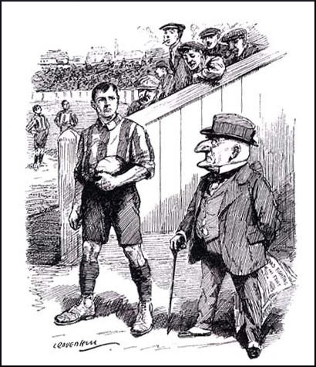

(Source 2) Arthur Conan Doyle, speech (6th September, 1914)
There was a time for all things in the world. There was a time for games, there was a time for business, and there was a time for domestic life. There was a time for everything, but there is only time for one thing now, and that thing is war. If the cricketer had a straight eye let him look along the barrel of a rifle. If a footballer had strength of limb let them serve and march in the field of battle.

(Source 3) Sermon given by Rev. W. Youard at St. Swithun's Church, East Grinstead (30th August, 1914).
I would say to every able-bodied young man in East Grinstead to offer yourself without delay in the service of your country. The Welsh Rugby Union Committee has passed a resolution declaring it the duty of all football players to join immediately. Blackheath Rugby Football Club has cancelled all its matches for the same reason. That is the right spirit. I hope it will be imitated by our own clubs. Go straight to the recruiting officer and offer yourself. That is the plain duty of every able-bodied young man today.
(Source 4) Recruitment Poster (December, 1914)
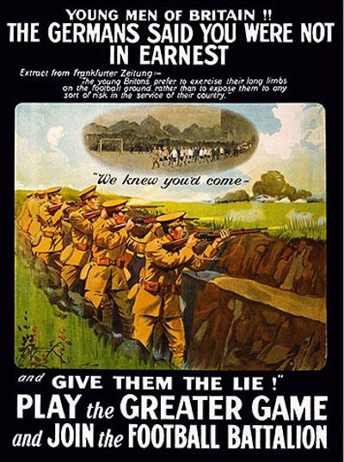

(Source 5) A. F. Pollard, letter to The Times (7th November, 1914)
Football is an excellent thing, even in time of war. Armies and navies can only be maintained so long as the community fulfils its function of producing means for their support; and healthy recreation is essential for efficient production. A man may be doing his duty in other fields than the front. But there is no excuse in diverting from the front thousands of athletes in order to feast the eyes of crowds of inactive spectators, who are either unfit to fight or else unfit to be fought for ... Every club who employs a professional player is bribing a needed recruit to refrain from enlistment, and every spectator who pays his gate money is contributing so much towards a German victory.
(Source 6) Recruits taking the oath in 1914.
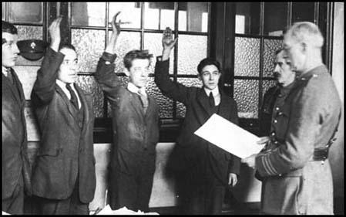

(Source 7) Athletic News (7th December, 1914)
The whole agitation is nothing less than an attempt by the ruling classes to stop the recreation on one day in the week of the masses ... What do they care for the poor man's sport? The poor are giving their lives for this country in thousands. In many cases they have nothing else ... There are those who could bear arms, but who have to stay at home and work for the army's requirements, and the country's needs. These should, according to a small clique of virulent snobs, be deprived of the one distraction that they have had for over thirty years.

(Source 9) The Sportsman (16th December 1914)
Yesterday’s meeting at the Fulham Town Hall, kindly lent for the purpose by the Mayor, Mr H. G. Norris, must be pronounced a success. It was arranged for the purpose of giving a send-off to the Footballers’ Battalion, officially known as the 17th Service Battalion Middlesex Regiment of Kitchener’s Army, and was attended by four or five hundred officials and players and others interested in the Association game. It had been intended to use the smaller hall, but the players trooped in as one party just before the time fixed (half-past 3) in such numbers that a move was made to the larger one, which was practically filled.
Mr W. Joynson-Hicks, M.P., occupied the chair, having on his right Mr H. G. Norris (the Mayor of Fulham) and on his left the Right Hon W. Hayes-Fisher, P.C., M.P., whilst others on the platform were the Right Hon Lord Kinnaird, K.T. (President of the Football Association), who could not arrive until some time after the meeting had been in progress, Col Grantham, Capt Whiffen, Capt Wells-Holland (Clapton Orient), Messrs J. B. Skeggs (Millwall) and F. J. Wall, who is acting as hon sec of the project. In the body of the hall were directors and officials of most of the leading professional clubs in and around the metropolis, including Messrs C. D. Crisp, J. Hall, and G. Morrell (The Arsenal), A. J. Palmer (Chelsea), S. Bourne (Crystal Palace), T. A. Descock, M. F. Cadman, and P. McWilliam (Tottenham Hotspur), P. Kelso (Fulham), and others too numerous to mention.
The Chairman opened proceedings with a splendid speech, in which he stated that most of those present were fully aware of the reason for which they had assembled, nor were they ignorant of the amount of correspondence and articles which had been appearing in the Press attacking footballers, football clubs, and even those who looked on. But the present was not a meeting called to answer those attacks. The country was at war with a great Power, Germany, and not until the stern struggle was over was it the time for recriminations. There was for the time being no party in the House of Commons, and he wished them to take the same line. Everybody to-day was for the State, everybody against Germany: all were anxious to make the path of those in charge easy, and assure ultimate victory. They could only endure, and then if they thought it worthwhile after the war was over they could answer their critics. His own view was that that magnificent meeting was an answer, and the best that could be made was to ensure the successful formation of the Footballers’ Battalion, or a Footballers’ Brigade.

Questions for Students
Question 1: Read the first two paragraphs of the introduction. Why was it difficult for professional footballers to join the British Army in August 1914?
Question 2: What is the cartoonist saying in source 2?
Question 3: The famous amateur footballer, Charles B. Fry, called for the abolition of football, demanding that all professional contracts be annulled and that no one below forty years of age be allowed to attend matches. What might a professional footballer had said to Fry in response to this statement?
Question 4: Study source 4? Why does the poster contain a quotation from a German newspaper?
Question 5: Read sources 2, 3, 5 and 7. Do they agree that professional footballers should join the armed forces in 1914?
Question 6: What is taking place in source 6?
Question 7: Study source 9. What did the government do to persuade footballers to join the British Army?

