Spartacus Educational Classroom Activity

Mary Tudor and Heretics http://spartacus-educational.com/ExTEU5.htm
Mary Tudor became queen of England in July 1553. She was the first woman to rule England in her own right. She appointed Bishop Stephen Gardiner as her Lord Chancellor. He had been imprisoned during the reign of Edward VI. Over the next two years Gardiner attempted to restore Catholicism in England. In the first Parliament held after Mary gained power most of the religious legislation of Edward's reign was repealed.
In November 1554, Mary's distant cousin, Reginald Pole, returned from exile, to become Archbishop of Canterbury. He shared Mary's devotion to the Catholic Church and wished to see England restored to full communion with Rome. Pole and Gardiner persuaded Parliament to revive former measures against heresy. These had been repealed under Henry VIII and Edward VI.
The Church leaders during the reign of Edward VI were arrested and charged with heresy. This included Thomas Cranmer, Nicolas Ridley, John Bradford, Hugh Latimer and John Rogers. Over the next four years around 280 people were burnt at the stake.

Primary Sources

(Source 1) Queen Mary, portrait by Antonis Mor (1554)

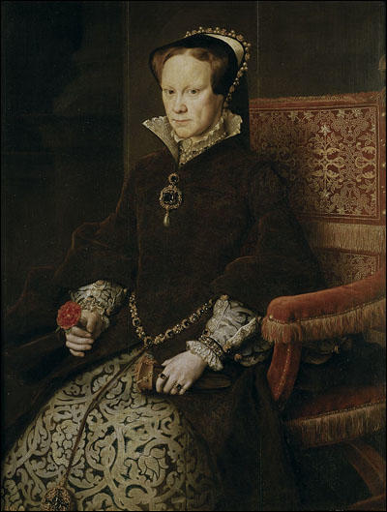

(Source 2) Jasper Ridley, Bloody Mary's Martyrs (2002)
In England in the reign of Queen Mary Tudor, for forty-five terrible months between 4 February 1555 and 10 November 1558, 283 Protestant martyrs - 227 men and 56 women - were burned alive. They have been remembered as martyrs for 400 years, and should be remembered today, though public recollection of them is beginning to fade. The Queen who was responsible for their suffering and death has gone down in history as "Bloody Mary", and her Roman Catholic co-religionists still suffer, at least in some respects, because of what she did to the martyrs. It is impossible for a King or Queen of England to be a Roman Catholic or to marry a Roman Catholic; and Bloody Mary is indirectly responsible for the hatred of "Papists" felt by the Protestants in Northern Ireland today.

(Source 3) Roger Lockyer, Tudor and Stuart Britain (1985)
Queen Mary was thirty-seven when the death of her half-brother brought her to the throne, and the catholics rejoiced at the prospect of a reign in which the old faith would be restored. Success seemed certain, for the Queen herself was popular.... For Mary politics were an aspect of religion and morality. Principle came first and she could see no virtue in compromise. The simplicity of her approach, combined with her natural stubbornness, explains why this well-intentioned woman became a symbol of intolerance and cruelty.

(Source 4) Christopher Morris, The Tudors (1955)
The punishment of death by burning was an appallingly cruel one, but it was not this that shocked contemporaries - after all, in an age that knew nothing of anaesthetics, a great deal of pain had to be endured by everybody at one time or another, and the taste for public executions, bear-baiting and cock-fighting suggests a callousness that blunted susceptibilities.
(Source 5) Thomas Cranmer burnt at the stake. An illustration from Foxe's Book of Martyrs (1563)
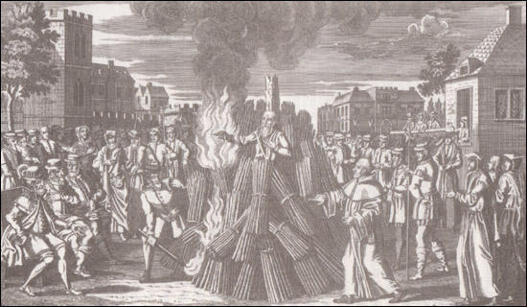

(Source 6) John Foxe, Book of Martyrs (1563)
Cranmer was miserable, not being able to die honestly or live dishonestly. In the meantime, Queen Mary secretly told Dr. Cole to prepare a funeral sermon for Cranmer's burning on March 21. On March 20, Cole went to Granmer to see if he was standing by his recantation. Assured that he was, Cole returned early on March 21 to give Cranmer some money for the poor. Cranmer realized what was about to happen to him. A Spanish friar came in to ask him to write his recantation out twice with his own hand and sign it, which he did, then Cranmer wrote a prayer and sermon that he secretly tucked into his shirt and waited.
Since it was a cold, rainy day, Cranmer was brought into St. Mary's Church with all the nobles, justices, and the crowd that had gathered. Dr: Cole gave his sermon, saying that although Cranmer had repented of his errors, the queen had other reasons for sending him to his death. He commended Cranrner for his works, saying he was unworthy of death but that masses would be said for his soul in all the churches of Oxford. Then Cole asked Cranmer to read his profession of faith, so everyone would see he was a good Catholic.
Cranmer's prayers and confession of faith were well within the doctrine of the Catholic Church until the very end, when he said, "And now I come to the great thing that troubles my conscience more than anything I ever did or said in my whole life, and that the publishing of a writing contrary to the truth, which now here I renounce and refuse, as things written by my hand contrary to the truth I believed ith my whole heart, written because I feared death. Since my hand offended, it will be punished: When I come to the fire, it first will be burned. As for the pope, I refuse him, as Christ's enemy and antichrist, with all his false doctrine. And as for the sacrament, I believe as I have taught in my book..."
The congregation was amazed at Cranmer's words, and the Catholic churchmen there raged, fretted, and fumed because they had nothing left to threaten him 'with. He could only die once, after all.
When he came to the place where Hugh Latimer and Ridley had been burned before him, Cranmer knelt down briefly to pray then undressed to his shirt, which hung down to his bare feet. His head, once he took off his caps, was so bare there wasn't a hair on it. His beard was long and thick, covering his face, which was so grave it moved both his friends and enemies.
As the fire approached him, Cranmer put his right hand into the flames, keeping it there until everyone could see it burned before his body was touched. "This unworthy right hand!" he called out often before he gave up the ghost.

(Source 7) Execution of Nicholas Ridley and Hugh Latimer.
An illustration from Foxe's Book of Martyrs (1563)
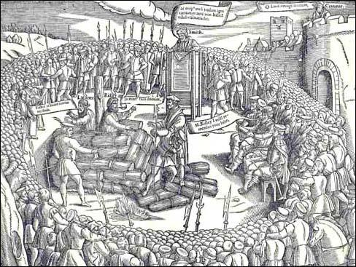

(Source 8) John Foxe, Book of Martyrs (1563)
Nicholas Ridley, by reason of the evil making of the fire unto him... burned clean all his nether parts before it touched the upper... Yet in all this torment he forgot not to call upon God... Let the fire come to me, I cannot burn. In which pains he laboured, till one of the standers by with his bill, pulled the faggots above, and when he saw the fire flame up, he wrested himself into that side. And when the flame touched the gunpowder, he was seen to stir no more.
(Source 9) Perotine Massey, Guillemine Gilbert, and Katharine Cawches being burnt at the
stake. An illustration from Foxe's Book of Martyrs (1563).
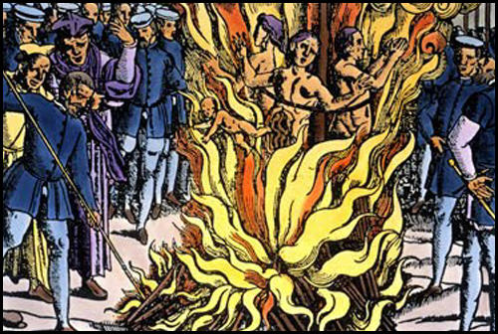

(Source 10) Edith Carey, 16th Century Social History in Guernsey (2000)
In this case, on leaving the Court the dismal procession will have filled up to Tower Hill, where there stakes were set up, the mother being placed in the middle. They were first strangled, but the rope broke before they were dead and they were cast out into the flames, and to Perotine Massey, in that raging furnace, a male child was born. He was picked out alive from the flames by a bystander the master gunner and surgeon "cannonier et cirugien" of the island called William House, and was brought by the Sheriff to the Bailiff, who said he was to be cast back into the flames. And by so saying has insured eternal infamy for his memory.
Harding, Father Parsons the Jesuit, and others have endeavoured to contradict these facts, but they are confirmed not only by the official records at the Greffe and the detailed trial report in Foxe's Book of Martyr's but the petition presented in 1562, to Her Majesty's Commissioners by Matthew Cauchés, brother to Catherine, embodying the above statements, gathered, as he says, "By the faithful relation both of French and English, of them which were then present, witnesses and lookers on;" pointing out that the verdict was due to "malicious hatred" by the Dean and his accomplices who had "illegally condemned his sister and his two nieces for heresy, they declaring all the time their innocence, and, moreover, the baby born of one of them being taken up and cast into the fire again, four being executed, though only three had been condemned."

(Source 11) John Foxe, Book of Martyrs (1563)
Amongst all and singular histories touched in this book before, as there be many pitiful, divers lamentable, some horrible and tragical; so is there none almost either in cruelty to be compared, or so far off from all compassion and sense of humanity, as this merciless fact of the papists, done in the isle of Guernsey, upon three women and an infant, whose names be these as follow:- Katharine Cawches, the mother; Guillemine Gilbert, the daughter; Perotine Massey, the other daughter; an infant, the son of Perotine...
The time then being come, when these three good servants and holy saints of God, the innocent mother with her two daughters, should suffer, in the place where they should consummate their martyrdom were three stakes set up. At the middle post was the mother, the eldest daughter on the right hand, the youngest on the other. They were first strangled, but the rope brake before they were dead, and so the poor women fell in the fire. Perotine, who was then great with child, did fall on her side, where happened a rueful sight, not only to the eyes of all that there stood, but also to the ears of all true-hearted Christians that shall read this history. For as the belly of the woman burst asunder by the vehemence of the flame, the infant, being a fair man-child, fell into the fire, and eftsoons being taken out of the fire by one William House, was laid upon the grass. Then was the child had to the provost, and from him to the bailiff, who gave censure that it should be carried back again, and cast into the fire. And so the infant, baptized in his own blood, to fill up the number of God's innocent saints, was both born and died a martyr, leaving behind to the world, which it never saw, a spectacle wherein the whole world may see the Herodin cruelty of this gracelesmeeoutation of catholic tormentors.

(Source 12)
Number of people executed for heresy in England and Wales.
Monarch | Date | Executed
Henry VII | 1485-1509 | 24
Henry VIII | 1509-1547 | 81
Edward VI | 1547-1553 | 2
Mary | 1553-1558 | 283
Elizabeth | 1558-1603 | 4

(Source 13) Jasper Ridley, Bloody Mary's Martyrs (2002)
Burnings were carried out in public, usually before large crowds of spectators. Many people came to enjoy the fun of watching a man burn; they often brought their children with them, and fathers lifted the smaller children on to their shoulders to enable them to see. Some of the spectators were Protestant supporters, for they thought it right to show solidarity and give moral support to their friends who were undergoing martyrdom.
The degree of suffering endured by the martyr varied in every case. In some ways the burnings in England were less cruel than in France and the Netherlands, where heretics who refused to recant often had their tongues bored through or cut off as they stood tied to the stake as an additional punishment before the faggots were lit. In England the heretic's friends were allowed to bribe the executioner to allow a bag of gunpowder to be fastened to the heretic's neck or waist, so that when the flames reached the gunpowder it would explode and immediately kill the heretic. But if it had been raining, and the faggots were damp; if the wood was green and fresh, as it often was in the spring; if it was a windy day, and the wind blew the flames away from the heretic and from the gunpowder; or if thee gunpowder was sodden, and did not explode; the heretic might live in agony for a long time.

Questions for Students
Question 1: Read source 2. Why was Queen Mary known as "Bloody Mary"? What were the long-term consequences of what has been described as "England's Terror"?
Question 2: How does the author of source 3 attempt to defend the rule of Queen Mary?
Question 3: Read source 6 and describe the events in source 5.
Question 4: Read sources 8 and 13 and then explain why friends of the people burnt at the stake arranged for a bag of gunpowder to be tied to them.
Question 5: Read the page on Perotine Massey and then use the information in sources 9, 10 and 11 to explain why Protestants in Guernsey attempted to prosecute Helier Gosselin after the death of Queen Mary.
Question 6: Most of the information about the burning of heretics in England comes from the book,Book of Martyrs (1563). Read about John Foxe and then describe the methods he used to write the book.
Question 7: Study source 12. Calculate the average number of executions per year for all of the Tudor monarchs. Add another column to your table and place the monarchs in rank order (highest at the top).

