Spartacus Educational Classroom Activity

Why were women hostile to Henry VIII's marriage to Anne Boleyn? http://spartacus-educational.com/ExTEU16.htm
For several years Henry VIII had been planning to divorce Catherine of Aragon. By 1526 he knew who he wanted to marry - Anne Boleyn. At the age of thirty-six he had fallen deeply in love with a woman some sixteen years his junior. Henry wrote Anne a series of passionate love letters. He told her: "Seeing I cannot be present in person with you, I send you the nearest thing to that possible, that is, my picture set in bracelets ... wishing myself in their place, when it shall please you." Soon afterwards he wrote during a hunting exhibition: "I send you this letter begging you to give me an account of the state you are in... I send you by this bearer a buck killed late last night by my hand, hoping, when you eat it, you will think of the hunter."
Henry VIII sent a message to the Pope Clement VII arguing that his marriage to Catherine had been invalid as she had previously been married to his brother Arthur. Rumours soon began circulating about Henry's plan to divorce Catherine of Aragon in order to marry Anne Boleyn. It was reported by Cardinal Jean du Bellay in May 1529 that Catherine had the support of the majority of women living in England at the time. "If the matter were to be decided by women, he (Henry VIII) would lose the battle, for they did not fail to encourage the queen (Catherine of Aragon) at her entrance and departure by their cries, telling her to care for nothing, and other such words."
In an attempt to gain support for his new queen, Henry VIII insisted on Parliament passing the 1534 Treason Act. The Act specified that all those were guilty of high treason who: “do maliciously wish, will or desire by words or writing, or by craft imagine, invent, practise, or attempt any bodily harm to be done or committed to the king's most royal person, the queen's or the heirs apparent, or to deprive them of any of their dignity, title or name of their royal estates, or slanderously and maliciously publish and pronounce, by express writing or words, that the king should be heretic, schismatic, tyrant, infidel or usurper of the crown."
Elizabeth Wood of Aylsham was one of those who was found guilty of this offence. Richard Southwell, who was employed by Thomas Cromwell, to investigate these crimes. Witnesses told Southwell that Wood had visited a shop owned by John Dix and had expressed support for the men found guilty of treason in Walsingham. She was, they said, "resting upon the shop windows of John Dix" when she spoke about these matters. Apparently she said "it was a pity that these Walsingham men were discovered, for we shall have never good world till" Henry VIII is removed "for we had never good world since this king reigned". Wood was found guilty of treason on 26th July, 1537, and executed soon afterwards.

Primary Sources

(Source 1) Anne Boleyn, copy of a portrait painted in about 1534

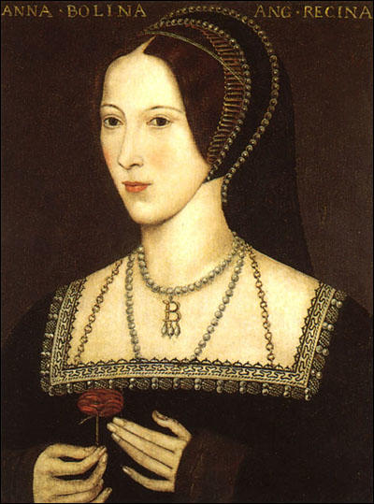

(Source 2) Edward Hall, History of England (1548)
Surely the most of the lay people of England, which knew not the law of God, sore murmured at the matter (Henry's proposed divorce) and much the more, because there was a gentlewoman in the court called Anne Boleyn.

(Source 3) George Cavendish, The Life and Death of Cardinal Wolsey (c. 1558)
And thus the world began to be full of wonderful rumours not heard of before in this realm... Then began other matters to brew and take place that occupied all men's heads with diverse imaginations, whose stomachs were therewith full filled without any perfect digestion. the long hid and secret love between the king and Mistress Anne Boleyn began to break out into every man's ears.

(Source 4) Nicholas Harpsfield, Treatise on the Pretended Divorce between Henry VIII and Catherine of Aragon (c. 1558) page 177
Then was there nothing so common and frequent and so tossed in every man's mouth, in all talks and at all tables, in all taverns, alehouses, and barbers' shops, yea, and in pulpits too, as was this matter, some well liking and allowing the divorce, some others highly detesting the same.

(Source 5) Lodovico Falier, report to King Charles V (24th November, 1531)
It is said that more than seven weeks ago a mob of from seven to eight thousand women of London went out of the town to seize Thomas Boleyn's daughter, the sweetheart of the king of England, who was supping at a villaon a river, the king not being with her; and having received notice of this, she escaped by crossing the river in a boat. The women had intended to kill her; and amongst the mob were many men, disguised as women. Nor has any great demonstration been made about this, because it was a thing done by women.

(Source 6) Eustace Chapuys, report to King Charles V (July, 1532)
The king was on his way to the northern counties where he intended to hunt ... when he suddenly changed his purpose and came back to town. The causes of his return are variously explained. Some say that for the last three or four days after he started on his journey, wherever he went accompanied by the lady (Anne Boleyn), the people on the road so earnestly requested him to recall the queen, his wife, and the women especially so insulted the royal mistress, hooting and hissing on her passage, that he was actually obliged to retrace his steps.

(Source 7) The London Chronicle (23rd August, 1532)
The 23rd day of August were two women beaten... naked from the waist upwards with rods and their ears nailed to the standard for because they said Queen Catherine was the true queen of England and not Queen Anne. And one of the women was big with child. And when these two women had thus been punished, they fortified their saying still, to die in the quarrel for Queen Catherine's sake.

(Source 8) Retha M. Warnicke, The Rise and Fall of Anne Boleyn (1989)
Although Anne had been crowned queen of England, many of the king's subjects continued to describe her as an adulteress. Numerous individuals, especially women, who felt personally threatened by her marriage to Henry because it was perceived as an assault on traditional family values, denounced the liaison of the royal couple. After they were wed, in fact, the protests seemed to have increased in number, for as long as the ex-queen was still living at least a part of the populace was more willing to accept Anne as the king's mistress than as his consort.

(Source 9) Sharon L. Jansen, Dangerous Talk and Strange Behaviour: Women and Popular Resistance to the Reforms of Henry VIII (1996)
The career of the Nun of Kent (Elizabeth Barton) was only the most spectacular of cases that led to the passage of a new Treason Act in 1534. Drafts of a new law had been written as early as 1530; the revised act was finally introduced in the November 1534 session of Parliament. After the passage of this bill there was danger in all kinds of words, even the kind we might typically ignore as harmless gossip, wild rumors, or foolish boasting.

Questions for Students
Question 1: Read the introduction and study sources 2, 3 and 4. How did the people living in England discover that Henry VIII wanted to divorce Catherine of Aragon and marry Anne Boleyn?
Question 2: Describe the different ways that women made it clear that they did not want Anne Boleyn as their queen.
Question 3: What measures did Henry VIII take in an attempt to make his subjects accept his decision to marry Anne Boleyn? What evidence is that this was not successful and further action had to be taken in 1534?
Question 4: Why does Retha M. Warnicke believe that women were so hostile to Henry's marriage to Anne Boleyn (source 8)?

